

MIT Machine Intelligence Community Technical Write-Up

**Scott H. Tan**

MIC Mentor: Shagan Sah, NVIDIA Corporation

**Abstract**

Machine intelligence could allow growers to save time and precisely control growing environments to maximize farm production. Here, we develop a machine intelligence platform to help farmers automate critical tasks such as pest monitoring and growth monitoring. First, the set up for monitoring insects in commercial greenhouses is designed. Second, contrast adjustment is tested to accurately count insects. Using grayscale images with gamma correction, local adaptive thresholding, dilation, and erosion, we demonstrate accurate insect counting of commercial farm pests. Third, deep convolutional neural network models are developed to classify plant species and insect species. We show we can achieve up to 93% validation accuracy and 85% testing accuracy for 30-class recognition with only 80 images in each training class using commercial farm data. Finally, we show we can quantify plant growth rate by segmenting green pixels and applying linear regression. These results highlight significant opportunities for machine intelligence to support indoor farming.

**Main**

Controlled-environment indoor farming has numerous benefits over conventional outdoor farming including higher crop yield per area and more robustness to the outside climate. However, pests remain a serious problem since they consume nutrients, contaminate crops, and can be dangerous to people. Today, commercial producers go to extensive lengths to protect their valuable growing operations. For example, greenhouse lettuce producers perform extensive monitoring that can take up to 8-hours day for just 5-acres of indoor farmland. Manually counting insect populations and classifying species can be a tiring and boring task. To make matters worse, head growers are faced with capacity-exceeding demand and labor shortages due to the COVID-19 pandemic.

Insect detection and counting could be automated using our technology platform. A client’s greenhouse is shown in Fig. 1a. Within the greenhouse, yellow sticky cards are mounted to monitor pests on every other structural pillar. Our technology sensor nodes, as shown in Fig. 1b, are lightweight and small enough to clip onto each bug card for real-time insect monitoring. As soon as the hardware is powered on, images are automatically captured and transmitted to the cloud for farmers to access on a web-based application. This allows for easy remote insect monitoring with high temporal and spatial resolution.

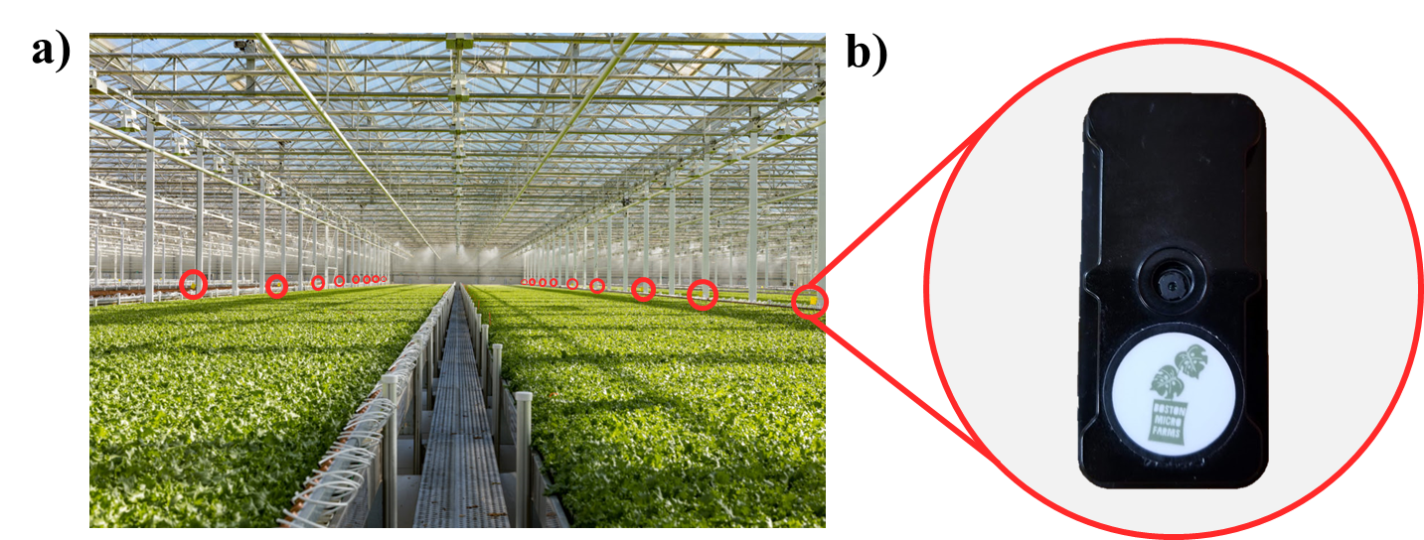

**Figure 1. Greenhouse monitoring systems.** a) Image showing rows of lettuce production in a Dutch greenhouse. Insect pads are placed at every other pillar to monitor pes populations. b) Image showing Boston Agritech camera hardware that can gather, process, and stream data.

Insect counting can be computed through image processing. Raw bug card images can be converted to grayscale, as shown in Fig. 2a. Grayscale images can undergo local adaptive thresholding, as shown in Fig. 2b. This method chooses the threshold based on the local mean intensity of neighboring pixels and is performed to reduce the influence of illumination variation. After local adaptive thresholding, dilation is applied to augment white regions. This is followed by erosion to reduce white regions back to original sizes, but with finer details being masked, as shown in Fig. 2c. Finally, counting is performed by adding up the number of connections between separate regions, as shown in Fig. 2d. From the grayscale image, 81 insects are counted on the bug card. Gamma correction could also enhance contrast. Gamma correction of 1.2 is applied to generate the image shown in Fig. 2e. Fig. 2f-h show image processing that results in a total count of 80 insects. An alternative contrast adjustment strategy is histogram equalization, which results in the image shown in Fig. 2i. Fig. 2j-l show image processing that results in a total count of 2619 insects, which is much higher than the true value. Grayscale with gamma correction contrast adjustment is selected since it yields the most accurate counting of the three contrast adjustment strategies tested. Fig. 3 a-e shows the counting pipeline executed on insect card data from the commercial greenhouse shown in Fig. 1. Accurate counting verifies our method can successfully count insects.

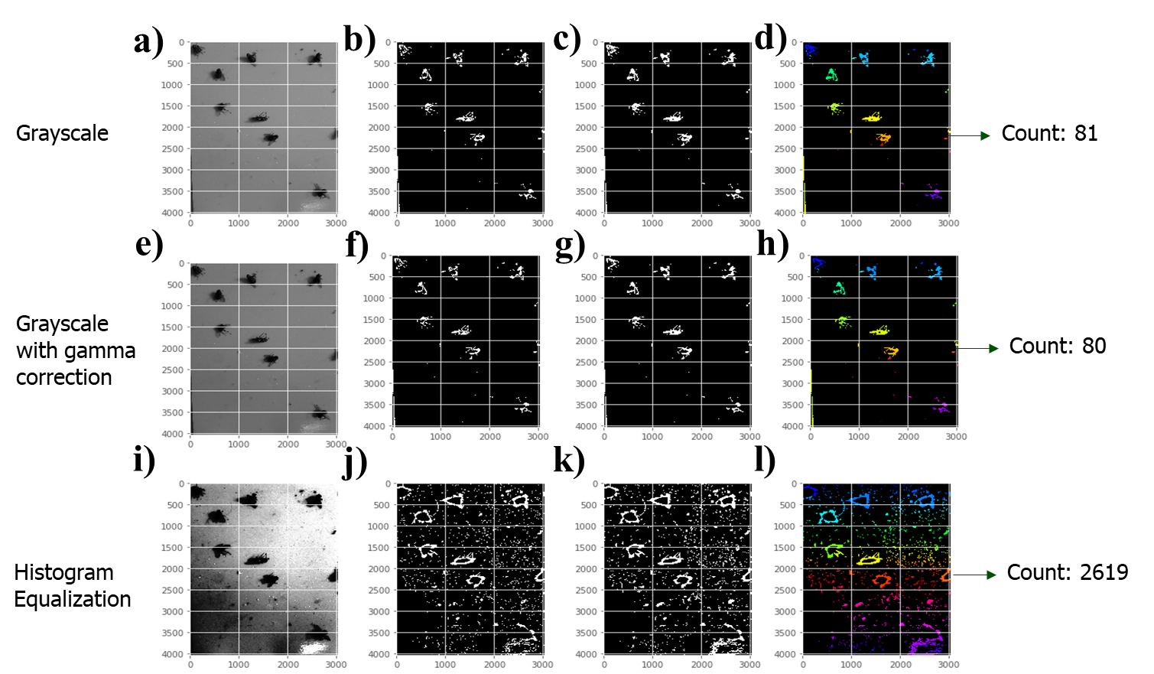

**Figure 2. Contrast adjustment to count insects.** a) Grayscale image of an insect pad. b) Local adaptive thresholding on grayscale image. c) Dilation is followed by erosion after local adaptive thresholding on grayscale image. d) Counting performed by connecting regions after erosion. Total count is 81 insects are counted from the grayscale image. e) Grayscale image with gamma correction. f) Local adaptive thresholding on grayscale image with gamma correction. g) Dilation is followed by erosion after local adaptive thresholding on grayscale image with gamma correction. h) Counting performed by connecting regions after erosion. Total count is 80 insects are counted from the grayscale image with gamma correction. i) Grayscale image with histogram equalization. J) Local adaptive thresholding on grayscale image with histogram equalization. k) Dilation is followed by erosion after local adaptive thresholding on grayscale image with histogram equalization. l) Counting performed by connecting regions after erosion. Total count is 2619 insects are counted from the grayscale image with histogram equalization.

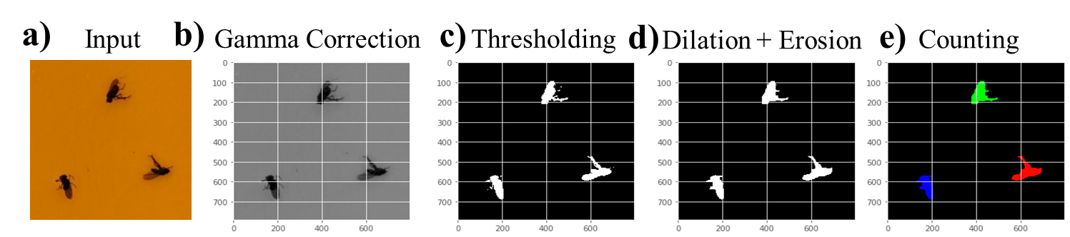

**Figure 3. Insect counting on commercial greenhouse data.** a) input of bug card from the greenhouse shown in Fig. 1. b) Image after gamma correction on the grayscale of the input. c) Image after local adaptive thresholding. d) Image after dilation followed by erosion. e) Three insects are counted accurately.

Species identification is critical since different species require different management strategies. Species classification can be executed using artificial neural networks. We evaluate classification of 1) plants, and 2) pests. Classification of plants is demonstrated with data from a farm in NY, as shown in Fig. 4a. Images are separated into 30 classes with 80 images per class. Our custom neural network model learns to accurately classify different plants with up to 93% validation accuracy and up to 85% testing accuracy, as shown in Fig. 4b. In addition to classifying plant species, different species of insects may also be present. As an example, a small training set with 6 images in each class (fly or gnat) and 3 images in each class in the validation set is tested. Pest data is collected from our hardware mounted on sticky traps, as shown in Fig. 4c. 100% validation accuracy is demonstrated in Fig. 4d. Additional data is required to engineer a model that is able to generalize better than the current solution. These results demonstrate that insect classification could be automated with reasonably high accuracy.

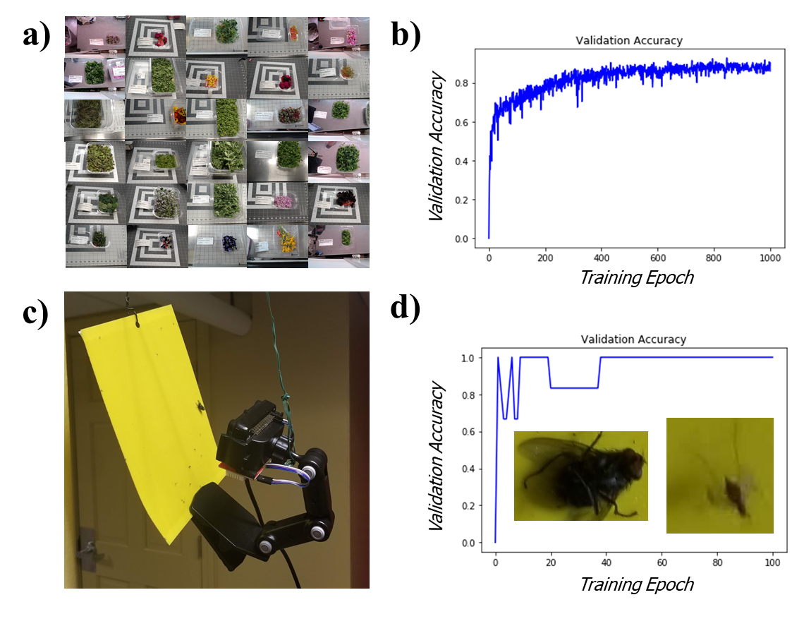

**Figure 4. Species Classification.** a) Example images from the training set used in plant species classification. 30 classes are formed with 80 images in each class in the training set. b) 93% validation accuracy and 85% testing accuracy has been demonstrated, which shows high image background noise could be tolerable with our method. c) Cameras can be clipped onto bug cards for easy monitoring. d) 100% validation accuracy is achieved for two class recognition with 6 training images in each class and 3 validation images. Example images are shown in the inset.

To estimate plant growth, background noise should be filtered as much as possible. In our experiments, we perform manual thresholding by observing green pixels with value exceeding 65 and with red pixels less than 123. A raw image of our lettuce is shown in Fig. 5a. Too much segmentation occurs when the red pixel threshold is reduced to 30, as shown in Fig. 5b. Red threshold at 123 allows for decent segmentation, as shown in Fig. 5c. Red threshold at 255 allows some segmentation, but the background wall also becomes visible, as shown in Fig. 5d.

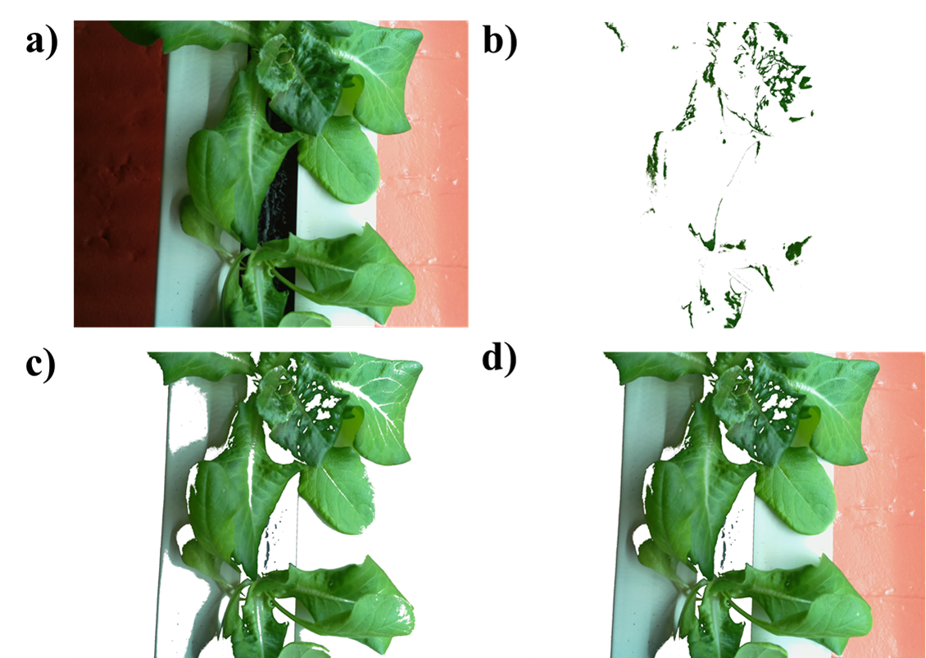

**Fig. 5. Color thresholding to count green pixels. a**) Input image. b) Processing with red threshold = 30. c) Processing with red threshold = 123 provides good segmentation results. d) Processing with red threshold = 255 permits the background to be part of our product.

Growth rate or decay rate can be quantified after segmenting green pixels. Here, we compare growth of with two lettuce varieties. Fig. 6a shows that the initial image of Grand Rapids lettuce. However, the lettuce decays to almost nothing, as shown in Fig 6b. In particular these decay at a rate of -13900 pixels per day, as shown in Fig. 6c. Fig. 6d shows the initial image of Buttercrunch lettuce. These grow rapidly over the course of a week, as shown in Fig. 6e. The growth rate of buttercrunch lettuce is calculated at 22330 pixels per day, as shown in Fig. 6f.

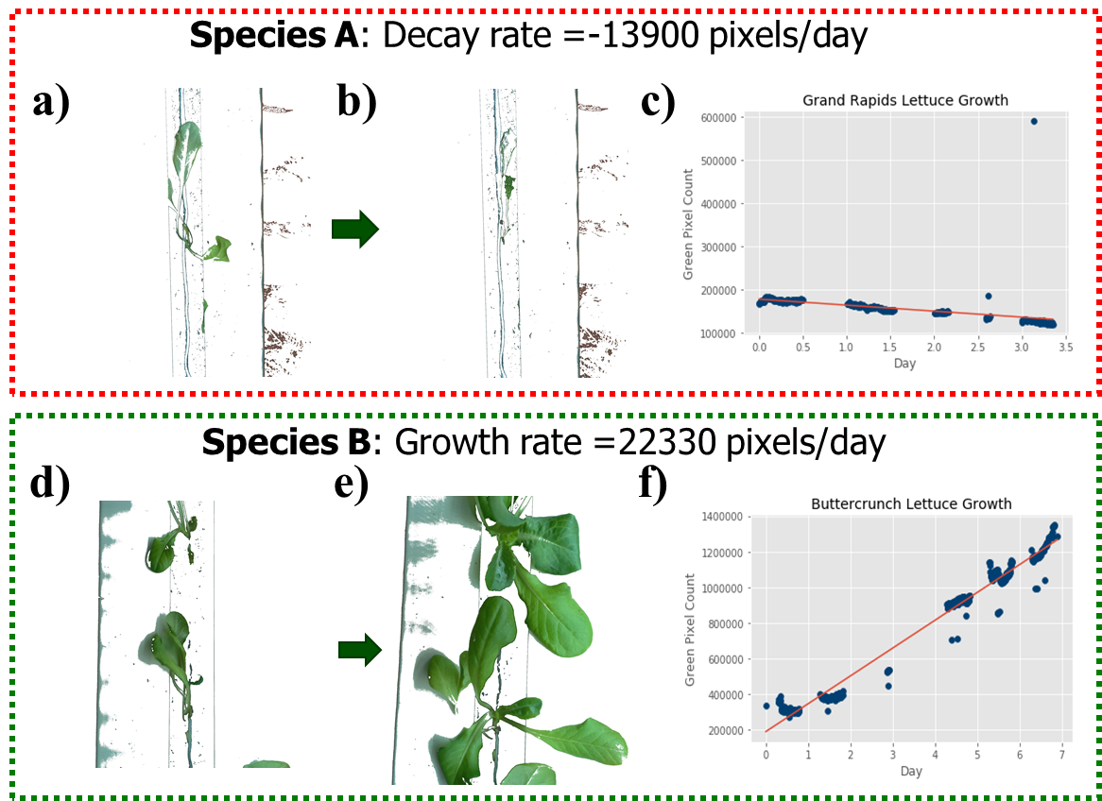

**Fig. 6. Segmentation and regression for species selection.** a) Grand Rapids Lettuce on May 2, 2020. b) Grand Rapids Lettuce on May 5, 2020. C) Lettuce decays linearly at a rate of -13900 pixels per day. d) Buttercrunch lettuce was planted at the same time as Grand Rapids. These demonstration of successful growth after 1 week, as shown in Fig. 2e. Lettuce in our experiment grows linearly at a rate of about 22330 pixels/day.

**Conclusions**

Indoor farming is an art that requires a great amount of skill. In this project, we develop machine intelligence to augment grower abilities with real-time insect detection and growth rate quantification. These tools could help the US produce more food on the same amount of land. By helping farmers utilize abundant data, we aim to make healthy and local produce available for everyone.